CSE 331 Spring 2026
Homework 1

SEED Labs - MD5 Collision Attack Lab

Acknowledgement:
I confirm that this submission, including all code and figures, is entirely my own work.

Full Name: _________
Student ID: _________
Date: ______________

2.1 Task 1: Generating Two Different Files with the Same MD5 Hash
All questions in the homework should be answered in English.
– Question 1. If the length of your prefix file is not multiple of 64, what is going to happen?
Answer:

– Question 2. Create a prefix file with exactly 64 bytes, and run the collision tool again, and see what happens.
Answer:

– Question 3. Are the data (128 bytes) generated by md5collgen completely different for the two output files? Please identify all the bytes that are different.
Answer:

Screenshots for task 1(Replace the three screenshots below with your own screenshots):
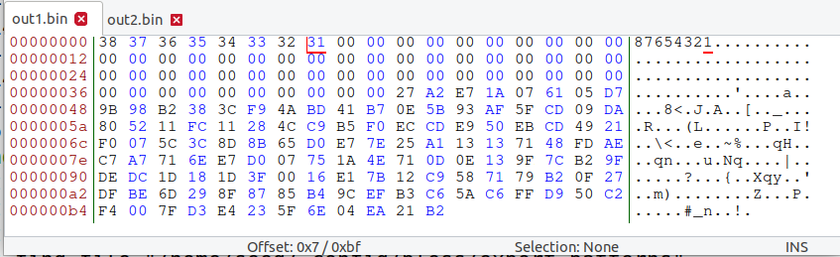
Figure 1 Contents of out1.bin
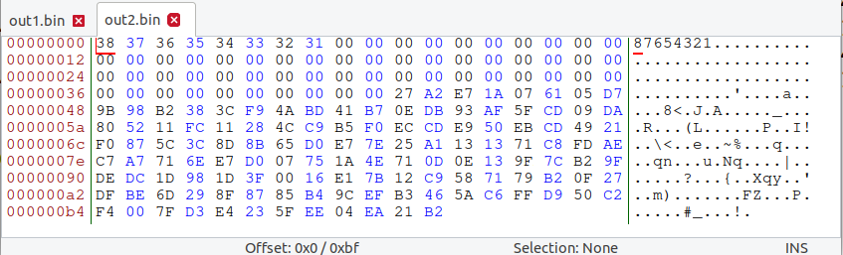
Figure 2 Content of out2.bin
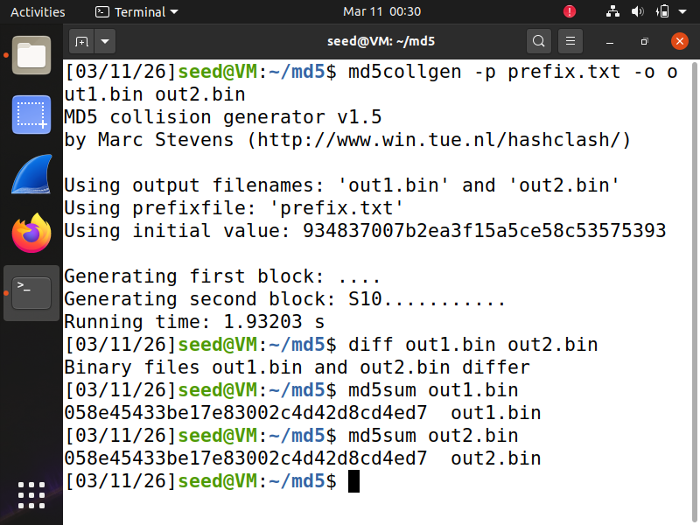
Figure 3 Terminal log showing that out1.bin and out2.bin are different files, yet have the same md5 hashcode
Note: All three of your screenshots for 2.1 should be on this page only. Your screenshots of the terminal window should show the entire window. Do not take pictures with your phone!

2.2 Task 2: Understanding MD5’s Property
“If inputs M and N have the same hash, adding the same suffix T to them will result in two outputs that have the same hash value.”
– Question 4. Explain how you demonstrate that the property above holds for MD5. Keep your answer short and precise.
Answer:

No screenshots are needed for this task.
2.3 Task 3: Generating Two Executable Files with the Same MD5 Hash
Look at the Figure 3 in the lab manual, and answer the following questions:
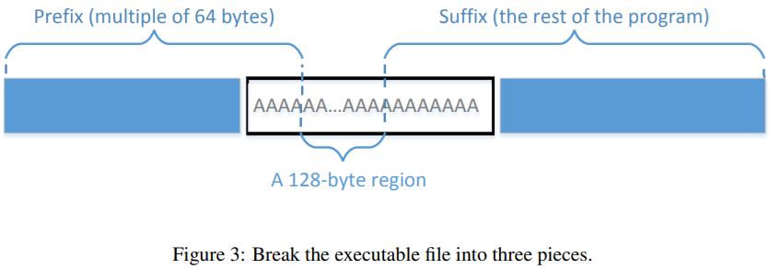
– Question 5. How long is your executable file? (exact number of bytes in decimal)
Answer:
– Question 6. How long is your prefix? (exact number of bytes in decimal)
Answer:
– Question 7. After compiling you C code and generating the executable file, what instructions did you run to generate two different 128-byte regions for the prefix?
Answer:

No screenshots are needed for this task.
2.4 Task 4: Making the Two Programs Behave Differently
Look at the Figure 4 in the lab manual, and answer the following questions:
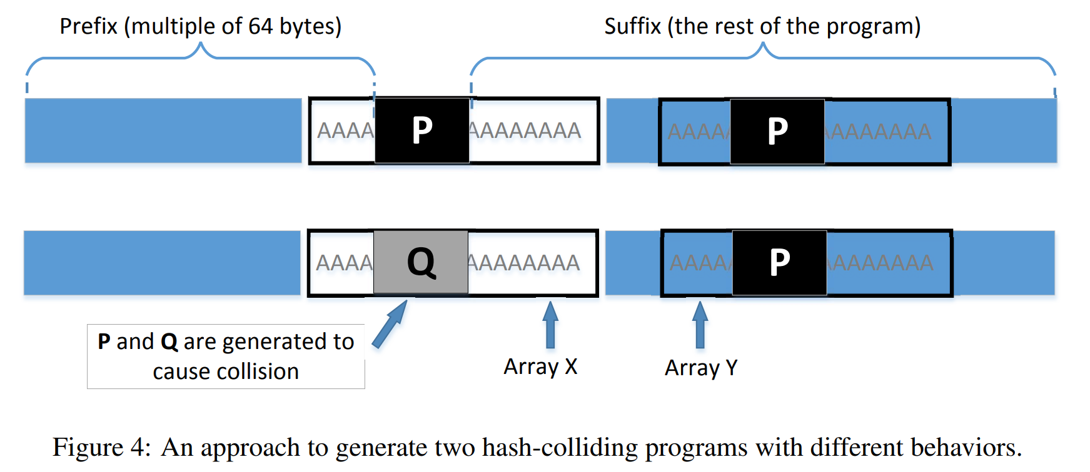
– Question 8. How long is your new executable file? (exact number of bytes in decimal)
Answer:
– Question 9. How long is your prefix? (exact number of bytes in decimal)
Answer:
– Question 10. What is the starting address of P in the entire executable file? (Hexadecimal, can be read from Bless or HxD or other hex editors)
Answer:

Screenshots for task 4(Replace the three screenshots below with your own screenshots):
Again, look at Figure 4 in the lab manual. The first screenshot should show P and P in the first executable.
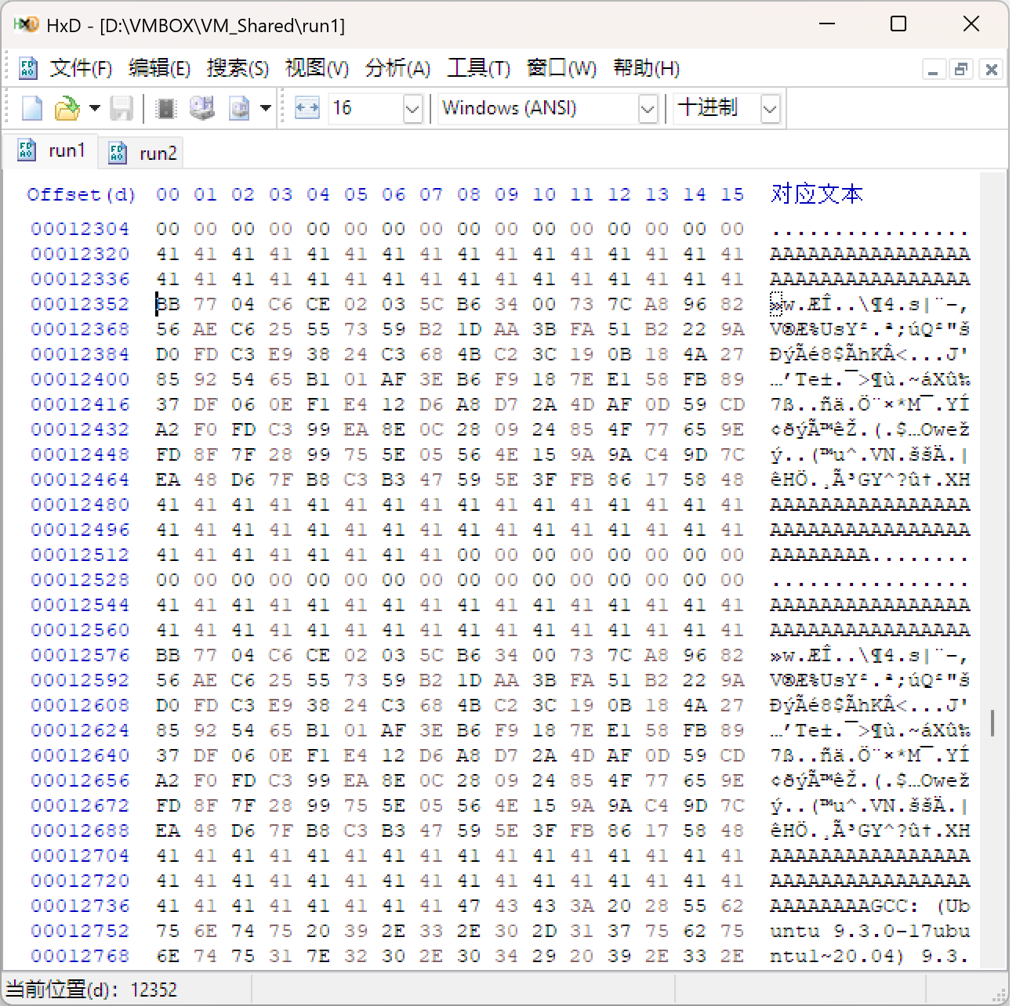
Figure 4 Contents of first executable, showing array X and Y contents, they both contain P

The second screenshot should show P and Q in the second executable. Mark at least one difference between P and Q.
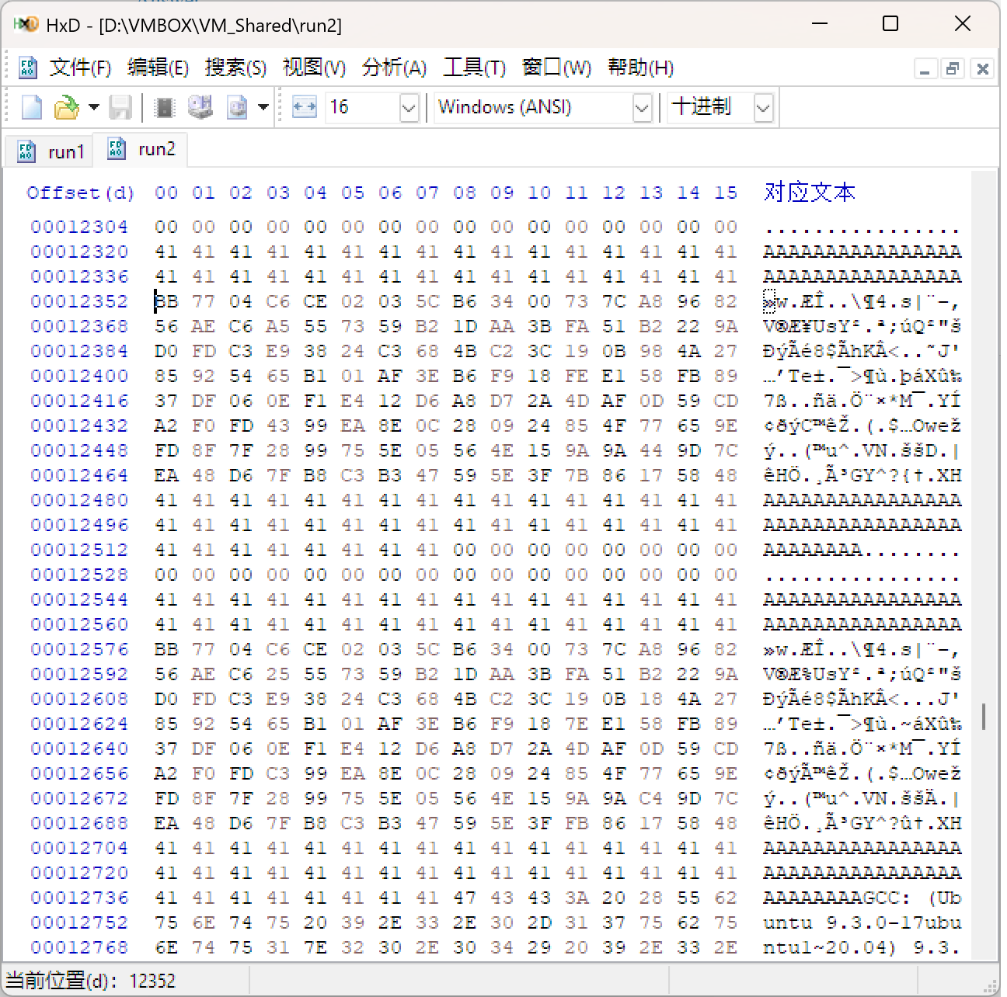
Figure 5 Contents of second executable, showing array X and Y contents, X contains Q, Y contains P

The third screenshot should show that the md5sum for both executables are the same, but their output results are different.
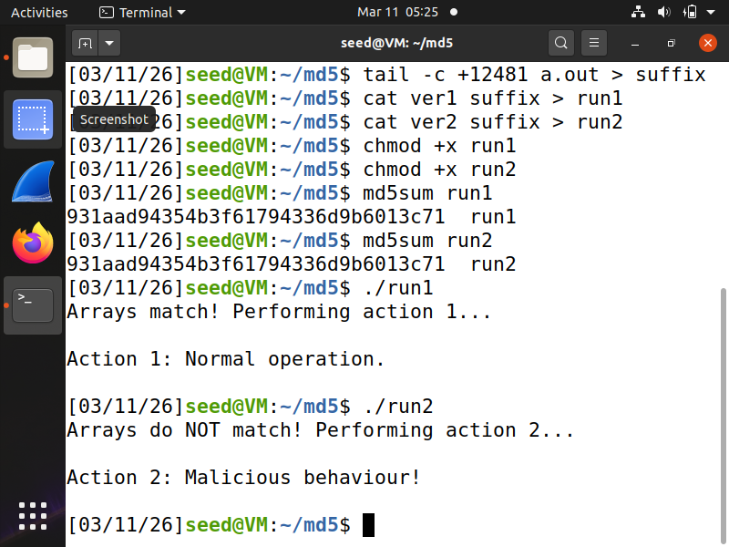
Figure 6 Terminal log showing that run1 and run2 have the same md5sum, but different outputs.

3 Submission
Convert the finished template to pdf and upload it together with three files in one zip package:
1. The source code file in step 2.4.
2. The first executable in step 2.4(contains P and P).
3. The second executable in step 2.4(contains P and Q).
Do not upload any other files.

